WEB TECHNOLOGY
Lab Assignment 3
Name: Atharva Kavade
Div: SY-AIDS-B
Roll No.: 12
PRN No: 12310269
HTML code
Main.html
<!DOCTYPE html>
<html lang="en">

<head>
<meta charset="UTF-8">
<meta name="viewport" content="width=device-width, initial-scale=1.0">
<title>Travel Guide - Explore the World</title>
<link href="https://stackpath.bootstrapcdn.com/bootstrap/4.5.2/css/bootstrap.min.css" rel="stylesheet">
<link rel="stylesheet" href="styles.css">
</head>

<body>
<header class="header">
<div class="container">
<div class="row align-items-center">
<div class="col-4">
<div class="logo">
<img src="pics/logo.jpg" alt="Travel Guide Logo">
</div>
</div>
<div class="col-8">
<nav class="navbar navbar-expand-lg navbar-light">
<button class="navbar-toggler" type="button" data-toggle="collapse" data-target="#navbarNav"
aria-controls="navbarNav" aria-expanded="false" aria-label="Toggle navigation">
<span class="navbar-toggler-icon"></span>
</button>
<div class="collapse navbar-collapse justify-content-end" id="navbarNav">
<ul class="navbar-nav">
<li class="nav-item">
<a href="#destinations" class="nav-link">Destinations</a>
</li>
<li class="nav-item">
<a href="#tours" class="nav-link">Tours</a>
</li>
<li class="nav-item">
<a href="#blog" class="nav-link">Blog</a>
</li>
<li class="nav-item">
<a href="submit.php" class="nav-link">Submit a Post</a>
</li>
<li class="nav-item">
<a href="#contact" class="nav-link">Contact Us</a>
</li>
</ul>
</div>
</nav>
</div>
</div>
</div>
</header>

<main>
<section class="video-section">
<div class="search-bar">
<input type="text" placeholder="Search for destinations, tours, blogs...">
<button><i class="fa fa-search"></i></button>
</div>
<video autoplay muted loop>
<source src="intro.mp4" type="video/mp4">
Your browser does not support the video tag.
</video>
</section>

<section class="hero" id="destinations">
<div class="container">
<h2 class="heading">Destinations</h2>
<div class="row" id="destinations-content"></div>
</div>
</section>

<section class="hero" id="blog">
<div class="container">
<h2 class="heading">Blog</h2>
<div class="row" id="blog-content"></div>
</div>
</section>

<section class="hero" id="submit-blog"></section>
<div class="container">
<h2>Submit a Blog Post</h2>
<form action="submit.php" method="post" enctype="multipart/form-data">
<div class="form-group">
<label for="title">Title</label>
<input type="text" class="form-control" name="title" required>
</div>
<div class="form-group">
<label for="author">Author</label>
<input type="text" class="form-control" name="author" required>
</div>
<div class="form-group">
<label for="content">Content</label>
<textarea class="form-control" name="content" rows="5" required></textarea>
</div>
<div class="form-group">
<label for="image">Image</label>
<input type="file" class="form-control" name="image" accept="image/*" required>
</div>
<button type="submit" class="btn btn-primary">Submit</button>
</form>
</div>
</section>

<section class="hero" id="contact">
<div class="overlay">
<h1>Contact Us</h1>
<p>Get in touch with our travel experts</p>
<button class="btn btn-primary">Contact Now</button>
</div>
</section>
</main>

<footer class="footer">
<p>&copy; 2024 Travel Guide. All rights reserved.</p>
</footer>

<script>
function createCardDest(image, title, description, destination) {
const charLimit = 150;
const truncatedDescription = description.length > charLimit ? description.substring(0, charLimit) + '...' : description;

return `
<div class="col-md-4 mb-4">
<div class="card">
<img src="${image}" class="card-img-top" alt="${title}">
<div class="card-body">
<h5 class="card-title">${title}</h5>
<p class="card-text">
<span class="truncated">${truncatedDescription}</span>
</p>
<a href="destination.html?destination=${destination}" class="btn btn-primary">Learn More</a>
</div>
</div>
</div>
`;
}

function createCard(image, title, description, link) {
const charLimit = 150;
const truncatedDescription = description.length > charLimit ? description.substring(0, charLimit) + '...' : description;

return `
<div class="col-md-4 mb-4">
<div class="card">
<img src="${image}" class="card-img-top" alt="${title}">
<div class="card-body">
<h5 class="card-title">${title}</h5>
<p class="card-text">
<span class="truncated">${truncatedDescription}</span>
</p>
<a href="${link}" class="btn btn-primary">Read More</a>
</div>
</div>
</div>
`;
}

fetch('data.json')
.then(response => response.json())
.then(data => {
const destinationsContent = document.getElementById('destinations-content');
const blogContent = document.getElementById('blog-content');

data.destinations.forEach(destination => {
destinationsContent.innerHTML += createCardDest(destination.image, destination.title, destination.description, destination.title);
});

data.blogs.forEach(blog => {
blogContent.innerHTML += createCard(blog.image, blog.title, blog.description, blog.link);
});
})
.catch(error => console.error('Error fetching data:', error));
</script>

<!-- Bootstrap and jQuery scripts -->
<script src="https://code.jquery.com/jquery-3.5.1.slim.min.js"></script>
<script src="https://cdn.jsdelivr.net/npm/@popperjs/core@2.9.2/dist/umd/popper.min.js"></script>
<script src="https://stackpath.bootstrapcdn.com/bootstrap/4.5.2/js/bootstrap.min.js"></script>
</body>

</html>

CSS File
* {
margin: 0;
padding: 0;
box-sizing: border-box;
font-family: 'Arial', sans-serif;
}

body {
display: flex;
flex-direction: column;
min-height: 100vh;
background-color: #f0f0f0;
color: #333;
}

.header {
background-color: rgba(0, 0, 0, 0.2);
padding: 10px 0;
position: fixed;
width: 100%;
z-index: 1000;
}

.logo img {
height: 50px;
}

.navbar-light .navbar-nav .nav-link {
color: #fff;
text-decoration: none;
font-size: 16px;
font-weight: bolder;
padding: 10px 15px;
}

.navbar-light .navbar-nav .nav-link:hover {
color: #1800b6;
}

.video-section {
height: 100vh;
display: flex;
justify-content: center;
align-items: center;
background-color: #000;
position: relative;
}

.video-section video {
width: 100%;
height: 100%;
object-fit: cover;
}

.search-bar {
position: absolute;
top: 50%;
left: 50%;
transform: translate(-50%, -50%);
z-index: 1;
width: 80%;
max-width: 600px;
display: flex;
box-shadow: 0 4px 8px rgba(0, 0, 0, 0.2);
border-radius: 50px;
overflow: hidden;
}

.search-bar input {
flex: 1;
padding: 10px 20px;
font-size: 1.2em;
border: none;
border-radius: 50px 0 0 50px;
outline: none;
}

.search-bar button {
background: #1800b6;
border: none;
padding: 10px 20px;
color: #fff;
margin: 0;
font-size: 1.2em;
cursor: pointer;
border-radius: 0 50px 50px 0;
}

.search-bar button:hover {
background: #2200ff;
}

.search-bar button i {
pointer-events: none;
}

.hero {
display: flex;
justify-content: center;
align-items: center;
position: relative;
text-align: center;
padding: 60px 20px;
}

.hero .overlay {
background: rgba(255, 255, 255, 0.7);
padding: 20px;
border-radius: 10px;
color: #333;
}

.card {
margin-bottom: 20px;
box-shadow: 0px 4px 8px rgba(0, 0, 0, 0.1);
transition: transform 0.3s ease-in-out;
height: 500px;
overflow: hidden;
position: relative;
}

.card:hover {
transform: scale(1.05);
}

.card-img-top {
border-top-left-radius: 10px;
border-top-right-radius: 10px;
}

.card-body {
padding: 20px;
}

button {
background-color: #1800b6;
color: #fff;
border: none;
padding: 10px 20px;
margin-top: 20px;
cursor: pointer;
border-radius: 5px;
}

.read-more {
position: absolute;
bottom: 10px;
right: 10px;
background-color: rgba(255, 255, 255, 0.8);
padding: 5px 10px;
cursor: pointer;
color: #1800b6;
border-radius: 5px;
}

button:hover {
background-color: #1800b6;
color: #ffffff;
}

.footer {
background-color: #1800b6;
color: #fff;
text-align: center;
padding: 10px;
margin-top: auto;
border-top: 1px solid #005f8b;
}

.destination-image {
width: 100%;
max-height: 500px;
object-fit: cover;
}

.info-section {
margin: 20px 0;
}

.attractions-list {
list-style: none;
padding: 0;
}

.attractions-list li {
background: #f8f9fa;
margin-bottom: 10px;
padding: 10px;
border-radius: 5px;
}

.destination-section {
position: relative;
height: 100vh;
display: flex;
justify-content: center;
align-items: center;
background-size: cover;
background-position: center;
overflow: hidden;
}

.destination-overlay {
position: absolute;
top: 0;
left: 0;
width: 100%;
height: 100%;
background: rgba(0, 0, 0, 0.2);
z-index: 1;
filter: blur(8px);
}

.destination-section::before {
content: "";
position: absolute;
top: 0;
left: 0;
width: 100%;
height: 100%;
background-size: cover;
background-position: center;
background-repeat: no-repeat;
opacity: 0.3;
}

.destination-content {
position: relative;
z-index: 2;
color: #fff;
text-align: center;
}

#destination-title {
font-family: 'Roboto', sans-serif;
font-size: 2.5em;
font-weight: 700;
color: #fff;
margin-bottom: 20px;
}

#destination-description {
font-family: 'Roboto', sans-serif;
font-size: 1.2em;
color: #fff;
}

Destinaion.html
<!DOCTYPE html>
<html lang="en">

<head>
<meta charset="UTF-8">
<meta name="viewport" content="width=device-width, initial-scale=1.0">
<title>Destination - Travel Guide</title>
<link href="https://stackpath.bootstrapcdn.com/bootstrap/4.5.2/css/bootstrap.min.css" rel="stylesheet">
<link href="https://fonts.googleapis.com/css2?family=Roboto:wght@400;700&display=swap" rel="stylesheet">
<link rel="stylesheet" href="styles.css">
</head>

<body>
<header class="header">
<div class="container">
<div class="row align-items-center">
<div class="col-4">
<div class="logo">
<img src="pics/logo.jpg" alt="Travel Guide Logo">
</div>
</div>
<div class="col-8">
<nav class="navbar navbar-expand-lg navbar-light">
<button class="navbar-toggler" type="button" data-toggle="collapse" data-target="#navbarNav"
aria-controls="navbarNav" aria-expanded="false" aria-label="Toggle navigation">
<span class="navbar-toggler-icon"></span>
</button>
<div class="collapse navbar-collapse justify-content-end" id="navbarNav">
<ul class="navbar-nav">
<li class="nav-item">
<a href="main.html" class="nav-link">Home</a>
</li>
<li class="nav-item">
<a href="main.html#destinations" class="nav-link">Destinations</a>
</li>
</ul>
</div>
</nav>
</div>
</div>
</div>
</header>

<main>
<section id="destination-details" class="destination-section">
<div class="destination-overlay"></div>
<div class="destination-content">
<div class="description-box">
<h2 id="destination-title"></h2>
<p id="destination-description"></p>
</div>
</div>
</section>

<section id="attractions" class="container my-5">
<h2>Main Attractions</h2>
<div id="attractions-list" class="row">
<!-- Attraction cards will be inserted here by JavaScript -->
</div>
</section>
</main>

<footer class="footer">
<p>&copy; 2024 Travel Guide. All rights reserved.</p>
</footer>

<script>
function getParameterByName(name) {
const url = new URL(window.location.href);
return url.searchParams.get(name);
}

const destinationTitle = getParameterByName('destination');

fetch('data.json')
.then(response => response.json())
.then(data => {
const destination = data.destinations.find(d => d.title === destinationTitle);

if (destination) {
document.getElementById('destination-title').innerText = destination.title;
document.getElementById('destination-description').innerText = destination.description;
document.querySelector('.destination-section').style.backgroundImage = `url('${destination.image}')`;

// Generate attraction cards
const attractionsList = document.getElementById('attractions-list');
data.destinations.forEach(d => {
if (d.title === destinationTitle) {
// Assuming attractions are listed in the destination object
const attractions = d.attractions || [];
attractions.forEach(attraction => {
const card = document.createElement('div');
card.className = 'col-md-4 mb-4';
card.innerHTML = `
<div class="card">
<img src="${attraction.image}" class="card-img-top" alt="${attraction.title}">
<div class="card-body">
<h5 class="card-title">${attraction.title}</h5>
<p class="card-text">${attraction.description}</p>
</div>
</div>
`;
attractionsList.appendChild(card);
});
}
});
} else {
document.getElementById('destination-details').innerHTML = '<p>Destination not found.</p>';
}
})
.catch(error => console.error('Error fetching data:', error));
</script>
<script src="https://code.jquery.com/jquery-3.5.1.slim.min.js"></script>
<script src="https://cdn.jsdelivr.net/npm/@popperjs/core@2.9.2/dist/umd/popper.min.js"></script>
<script src="https://stackpath.bootstrapcdn.com/bootstrap/4.5.2/js/bootstrap.min.js"></script>
</body>

</html>

Data.json
{
"destinations": [
{
"image": "pics/paris.jpg",
"title": "Paris",
"description": "As the world's best place to visit, it's no surprise that the electrifying City of Light tops this list. France's capital city is a year-round tourist destination with iconic attractions like the Louvre and the Eiffel Tower and incredible architecture (think: the dazzling Basilique du Sacré-Coeur).",
"attractions": [
{
"image": "pics/louvre.jpg",
"title": "Louvre Museum",
"description": "The Louvre is the world's largest art museum and a historic monument in Paris, France."
},
{
"image": "pics/eiffel_tower.jpg",
"title": "Eiffel Tower",
"description": "The Eiffel Tower is a wrought-iron lattice tower on the Champ de Mars in Paris, France."
},
{
"image": "pics/arc-de-triomphe-paris.jpg",
"title": "Arc de Triomphe",
"description": "The Arc de Triomphe honours those who fought and died for France in the French Revolutionary and Napoleonic Wars."
}
]
},
{
"image": "pics/nice.jpg",
"title": "Nice",
"description": "Glamorous Nice occupies a picturesque spot along the French Riviera. Beach bums and culture hounds alike will enjoy the city's pebbly shores, engaging museums, boutique shops and Baroque-style palaces.",
"attractions": [
{
"image": "pics/promenade_des_anglais.jpg",
"title": "Promenade des Anglais",
"description": "A long, scenic boulevard along the Mediterranean Sea, ideal for strolling and people-watching."
},
{
"image": "pics/Massena-Museum.jpg",
"title": "Massena Museum",
"description": "The Villa Masséna is located right next to the famous Negresco hotel in Nice. It houses the Massena Museum presenting the history of Nice and the region, as well as valuable memorabilia of Napoleon."
},
{
"image": "pics/saint-nicolas.jpg",
"title": "Saint Nicolas Cathedral",
"description": "The Saint-Nicolas Cathedral in Nice is the largest Russian Orthodox church outside Russia. The impressive sacred building with the ground plan of a cross and its five domes is located in a small park on the Boulevard du Tzarévitch and is one of the most visited sights in Nice."
}
]
},
{
"image": "pics/burgundy.jpg",
"title": "Burgundy",
"description": "Another popular wine region, Burgundy is home to rolling hills, superior cuisine and an array of vineyards. Those visiting Burgundy must spend time exploring the medieval villages, historical abbeys and museums that call this area home.",
"attractions": [
{
"image": "pics/01b.jpg",
"title": "Dijon Ducal Palace",
"description": "One of Dijon’s most important historical landmarks (and included in the Historic Center of Dijon UNESCO World Heritage Site), the Dijon Ducal Palace was, for centuries, the seat of Burgundian power."
},
{
"image": "pics/2b.jpg",
"title": "Hospices de Beaune",
"description": "A UNESCO World Heritage Site, the Hospices de Beaune (aka the Hôtel-Dieu de Beaune is one of Burgundy’s most storied buildings. Founded as a charitable hospital in 1443, the landmark is known for its turrets, colorful roof tiles, and pretty courtyards—as well as the annual wine auction it hosts."
}
]
},
{
"image": "pics/toulouse.jpg",
"title": "Toulouse",
"description": "Dubbed la Ville Rose (the Pink City) due to the prominence of distinctive clay bricks in its architecture, Toulouse is a feast for the eyes. Throughout this city, which is located in the South of France, you'll find marvels like the neoclassical Le Capitole on the main square, the stately Basilica of Saint-Sernin (an 11th-century UNESCO site)",
"attractions": [
{
"image": "pics/1t.jpeg",
"title": "Basilica of Saint-Sernin",
"description": "A Romanesque church and UNESCO World Heritage Site in Toulouse, known for its stunning architecture."
},
{
"image": "pics/2t.jpeg",
"title": "Couvent des Jacobins",
"description": "The Church of the Jacobins is a deconsecrated Roman Catholic church located in Toulouse, France. It is a large brick building whose construction started in 1230, and whose architecture influenced the development of the Gothique méridional (Southern French Gothic) style."
}
]
},
{
"image": "pics/eze.jpg",
"title": "Eze",
"description": "Located on the French Riviera about 8 miles east of Nice, the tiny hilltop village of Èze makes for an excellent day trip. The best way to spend your time in this medieval town is meandering through its cobbled streets that look as though they've been pulled from a postcard.",
"attractions": [
{
"image": "pics/1e.jpg",
"title": "Eze Village",
"description": "A picturesque medieval village with breathtaking views of the Mediterranean."
}
]
},
{
"image": "pics/lyon.jpeg",
"title": "Lyon",
"description": "While it may not be as well-known as big-name cities like Paris, Lyon competes with the best of them. Despite being the third-largest city in France, Lyon is much calmer and less touristy than other similarly sized destinations.",
"attractions": [
{
"image": "pics/basilica_of_notre_dame_de_fourviere.jpg",
"title": "Basilica of Notre-Dame de Fourvière",
"description": "A prominent basilica located on Fourvière Hill, offering panoramic views of Lyon."
}
]
}
],
"tours": [
{
"image": "tour1.jpg",
"title": "Exclusive Tour 1",
"description": "Handpicked tours for an unforgettable experience"
},
{
"image": "tour2.jpg",
"title": "Exclusive Tour 2",
"description": "Handpicked tours for an unforgettable experience"
},
{
"image": "tour3.jpg",
"title": "Exclusive Tour 3",
"description": "Handpicked tours for an unforgettable experience"
}
],
"blogs": [
{
"image": "pics/blog1.png",
"title": "Fracne Travel Tips",
"link": "https://www.francetraveltips.com/",
"description": "I travel to France often and love to share insights about unique sites and experiences—those that are not always written about in tour books: active, outdoor, culinary, arts and entertainment, and learning experiences in Paris and throughout France."
},
{
"image": "pics/blog2.png",
"title": "Me ssy Nessy Chic",
"link": "https://www.messynessychic.com/",
"description": "Every summer we run into the same problem: too many amazing festivals, too little time. Then we caught wind of the long lost Delphic Festivals, which makes every concert we’ve ever been to pale in comparison to its over-the-top, 1920s interpretation of Greek merrymaking. "
},
{
"image": "pics/blog3.png",
"title": "The Provence Post",
"link": "https://theprovencepost.blogspot.com/",
"description": "Read inspiring stories and tips"
}
]
}

Index.php
<?php
$blogs = json_decode(file_get_contents('blogs.json'), true);
?>

<!DOCTYPE html>
<html lang="en">
<head>
<meta charset="UTF-8">
<meta name="viewport" content="width=device-width, initial-scale=1.0">
<title>Travel Blog</title>
<link href="https://stackpath.bootstrapcdn.com/bootstrap/4.5.2/css/bootstrap.min.css" rel="stylesheet">
<link rel="stylesheet" href="styles.css">
</head>
<body>
<header class="header">
<div class="container">
<h1>Travel Blog</h1>
<nav>
<a href="index.php">Home</a>
<a href="submit.php">Submit a Post</a>
</nav>
</div>
</header>

<main class="container my-5">
<div id="blog-content" class="row">
<?php foreach ($blogs as $blog): ?>
<div class="col-md-4 mb-4">
<div class="card">
<img src="<?php echo $blog['image']; ?>" class="card-img-top" alt="<?php echo $blog['title']; ?>">
<div class="card-body">
<h5 class="card-title"><?php echo $blog['title']; ?></h5>
<p class="card-text"><?php echo $blog['content']; ?></p>
<p class="card-text"><small><?php echo $blog['author']; ?> | <?php echo $blog['date']; ?></small></p>
</div>
</div>
</div>
<?php endforeach; ?>
</div>
</main>

<footer class="footer">
<p>&copy; 2024 Travel Guide. All rights reserved.</p>
</footer>
</body>
</html>

Submit.php
<?php
if ($_SERVER['REQUEST_METHOD'] === 'POST') {
$title = $_POST['title'];
$author = $_POST['author'];
$content = $_POST['content'];
$date = date('Y-m-d');
$image = 'uploads/' . basename($_FILES['image']['name']);

// Validate data here (e.g., check if fields are empty)

// Move uploaded file
move_uploaded_file($_FILES['image']['tmp_name'], $image);

// Read existing blog posts
$blogs = json_decode(file_get_contents('blogs.json'), true);

// Append new blog post
$blogs[] = [
'title' => $title,
'author' => $author,
'content' => $content,
'date' => $date,
'image' => $image
];

// Save back to JSON file
file_put_contents('blogs.json', json_encode($blogs));

header('Location: main.html'); // Redirect to the main page
}
?>

<!DOCTYPE html>
<html lang="en">
<head>
<meta charset="UTF-8">
<meta name="viewport" content="width=device-width, initial-scale=1.0">
<title>Submit a Post</title>
<link href="https://stackpath.bootstrapcdn.com/bootstrap/4.5.2/css/bootstrap.min.css" rel="stylesheet">
</head>
<body>
<div class="container my-5">
<h2>Submit a Blog Post</h2>
<form action="submit.php" method="post" enctype="multipart/form-data">
<div class="form-group">
<label for="title">Title</label>
<input type="text" class="form-control" name="title" required>
</div>
<div class="form-group">
<label for="author">Author</label>
<input type="text" class="form-control" name="author" required>
</div>
<div class="form-group">
<label for="content">Content</label>
<textarea class="form-control" name="content" rows="5" required></textarea>
</div>
<div class="form-group">
<label for="image">Image</label>
<input type="file" class="form-control" name="image" accept="image/*" required>
</div>
<button type="submit" class="btn btn-primary">Submit</button>
</form>
</div>
</body>
</html>

Github Repository link
https://github.com/atharvadk/Web-tech.git
Live Images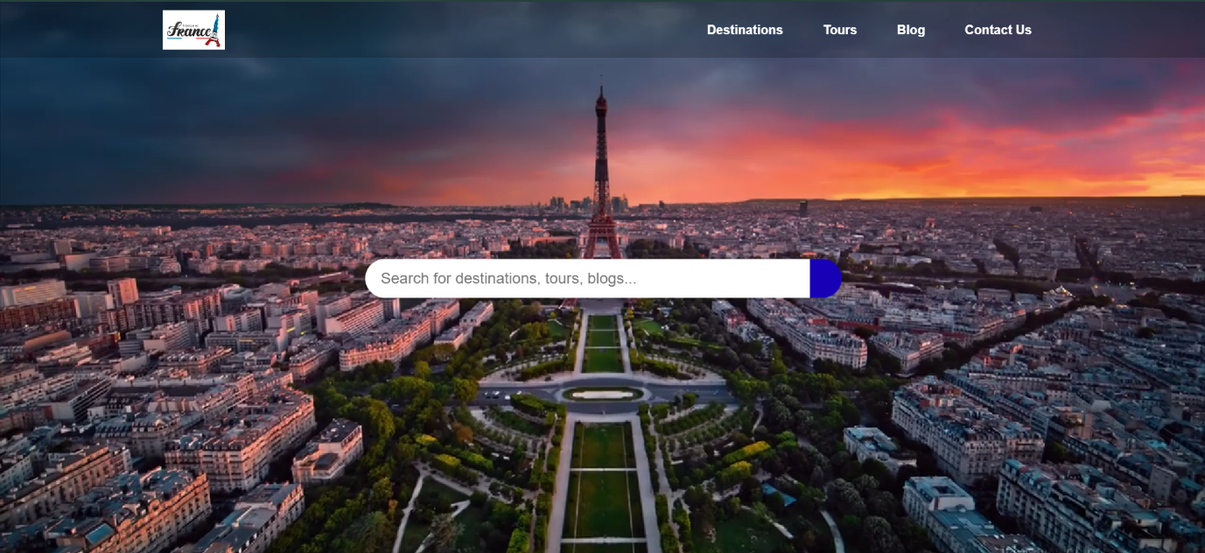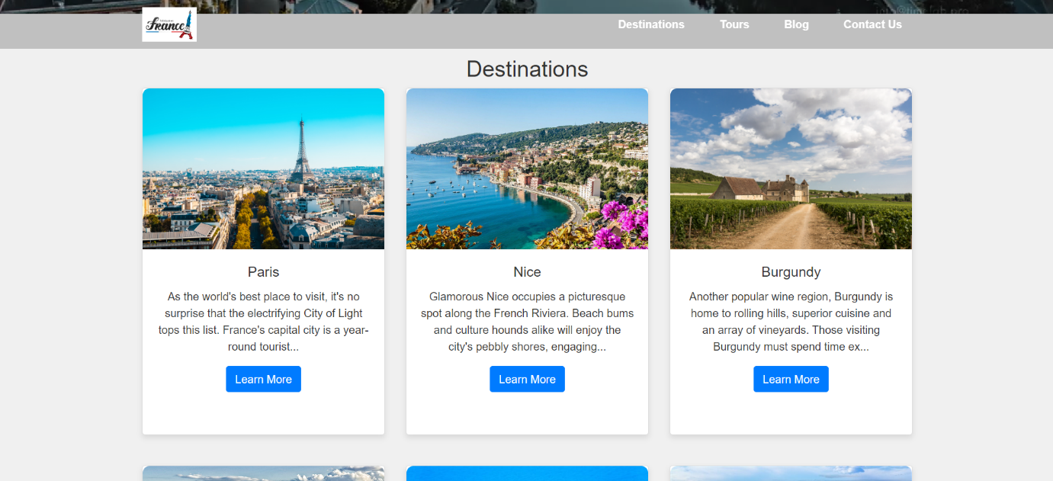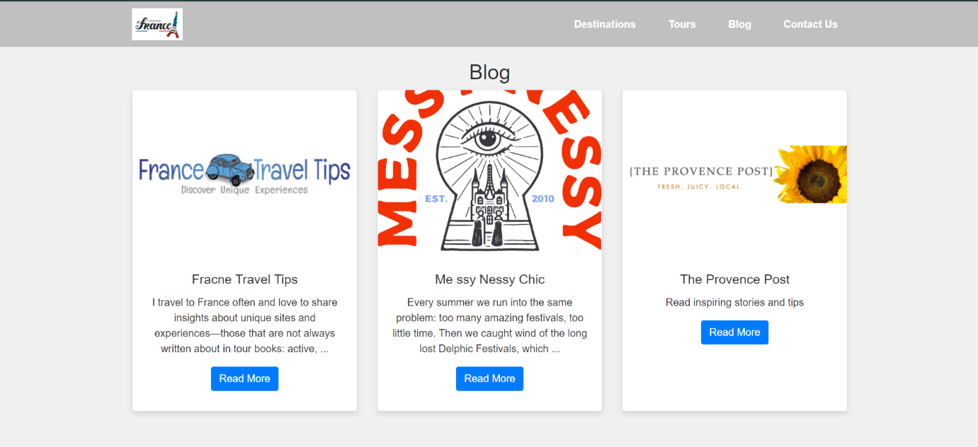
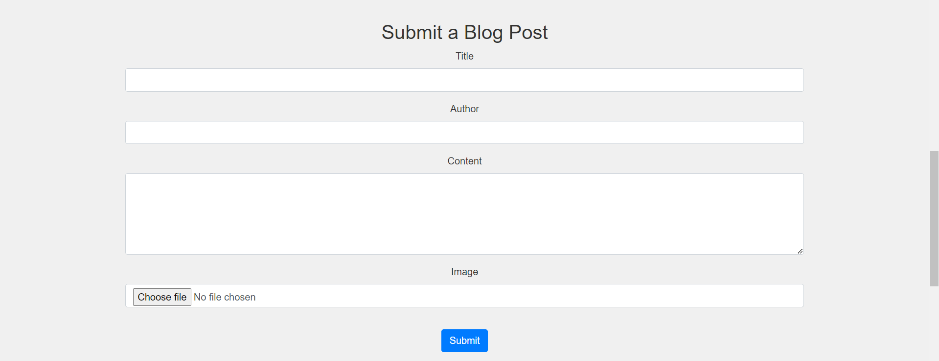

Destination page images
